**Project Name:** TRANSFORMING EDA TO DATABASE

**Name : Asma Khan**

**About the Project:**

Our project revolves around demystifying the Play Store data puzzle to empower app developers in the Android realm. The main goal is to sift through app details and user reviews, distilling insights that can guide developers towards making smarter decisions for better user engagement.

**Understanding the Playground:** To kick off, we gather a trove of data from the Play Store—details like app categories, ratings, and sizes. We also grab user reviews, aiming for a comprehensive understanding of what factors contribute to app success.

**Getting Acquainted with the Data:** Taking a closer look at the data, we ensure it's all in order and fill in any blanks. Quick snapshots of ratings and sizes give us a bird's eye view of trends and patterns.

**Cracking the Category Code:** Next, we dive into how apps perform across different categories. This helps identify the hotspots—categories that are currently rocking the charts. Developers can then tailor their efforts to align with these trends.

**User Vibes Matter:** We tap into customer reviews to uncover the feelings users have about apps. This sentiment analysis helps developers in refining their creations, prioritising features that users love and fixing areas that might be irking them.

**Connecting the Data Dots:** We play matchmaker with different data points—ratings, size, and category—seeking out connections that reveal what makes users tick. This detective work allows developers to focus on aspects that strongly influence higher app engagement.

**Size Check:** Ever wondered if app size affects how users rate an app? We investigate that too, providing insights into the optimal app size for maximum user satisfaction.

**What We Serve on the Plate:** At the project's end, we serve up insights and recommendations on a platter for developers. This includes understanding user preferences, strategies to shine in specific categories, and actionable feedback from users for app improvement.

**What We Expect:** This project isn’t just about numbers; it's about giving developers the keys to app success. We expect to pinpoint factors crucial for app triumph, provide a peek into user preferences, and hand over practical tips for developers to level up their apps.

In essence, our project is about simplifying the complex world of Play Store data, offering a roadmap for developers to navigate towards app success. It's not just about numbers; it's about understanding what users want and guiding developers on how to deliver just that.

**Dataset Link:**

<https://drive.google.com/file/d/1GxOrINkagQ-6bFWLS8vSP_TwszEONg3x/view?usp=sharing>

**Data Visualization By Tableau:**

**Let’s Begin!**

1. **Type and installations:**

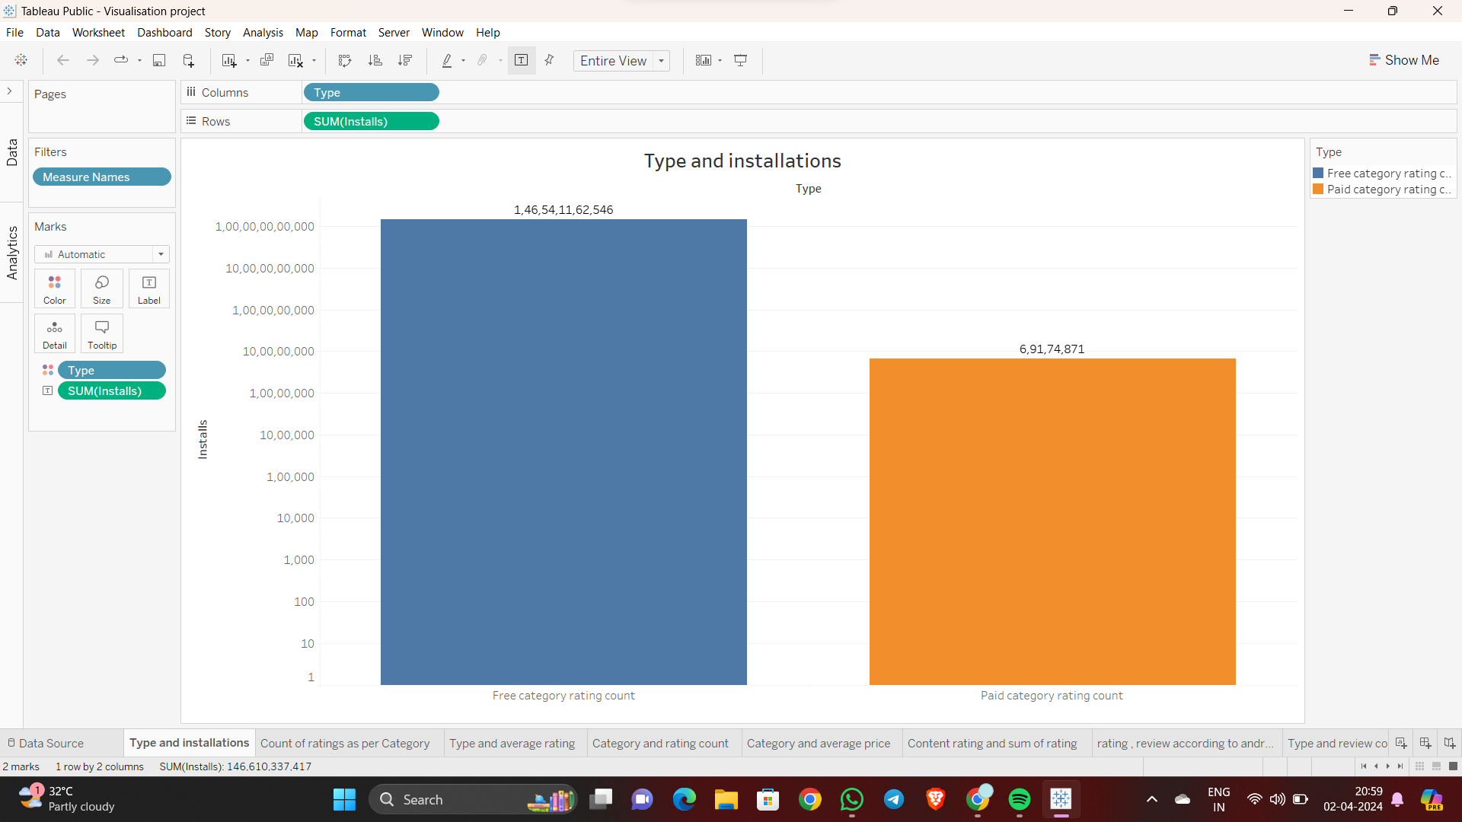

**Insight**

We can see here that free category applications are having the highest number of installations as compared to the paid applications.

**Business Impact**

To visualise types and installations data type columns' rows sum with a horizontal bar chart can provide quick insights into the distribution of data types and their corresponding installation counts. This helps identify the most prevalent data types and their impact on business decisions, such as resource allocation, feature prioritisation, and infrastructure planning.

**2. Count of ratings as per Category:**

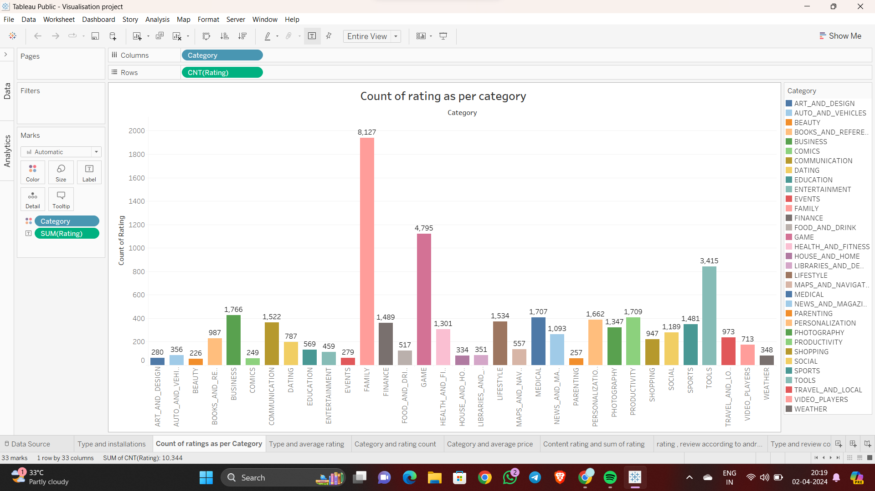

**Insight**

We can see that family category apps have the highest rating followed by games, tools, and so on.

**Business Impact**

The insights gained from the scatter plot can help developers understand the most popular categories of apps. This information can be used to develop new apps in popular categories or to improve existing apps in popular categories. This can help to attract more users and increase revenue.

**3. Type and average rating:**

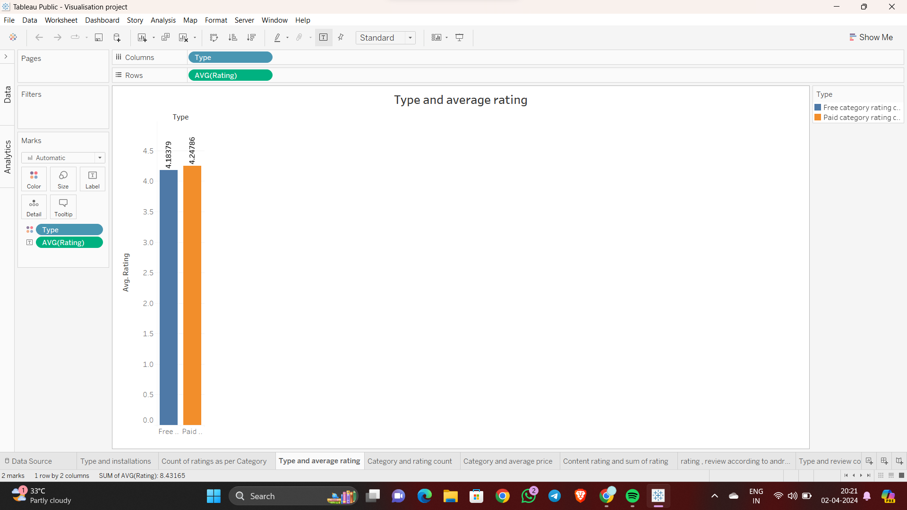

**Insight**

The average rating of paid category apps are 4.24786 where as free category apps are having 4.18379

**Business Impact**

Visualising types alongside their average rating in a horizontal bar chart offers a clear view of which types tend to garner higher or lower ratings. This insight aids in understanding customer preferences, guiding product development efforts, and optimising marketing strategies to focus on high-rated content, ultimately enhancing customer satisfaction and retention.

**4. Category and rating count:**

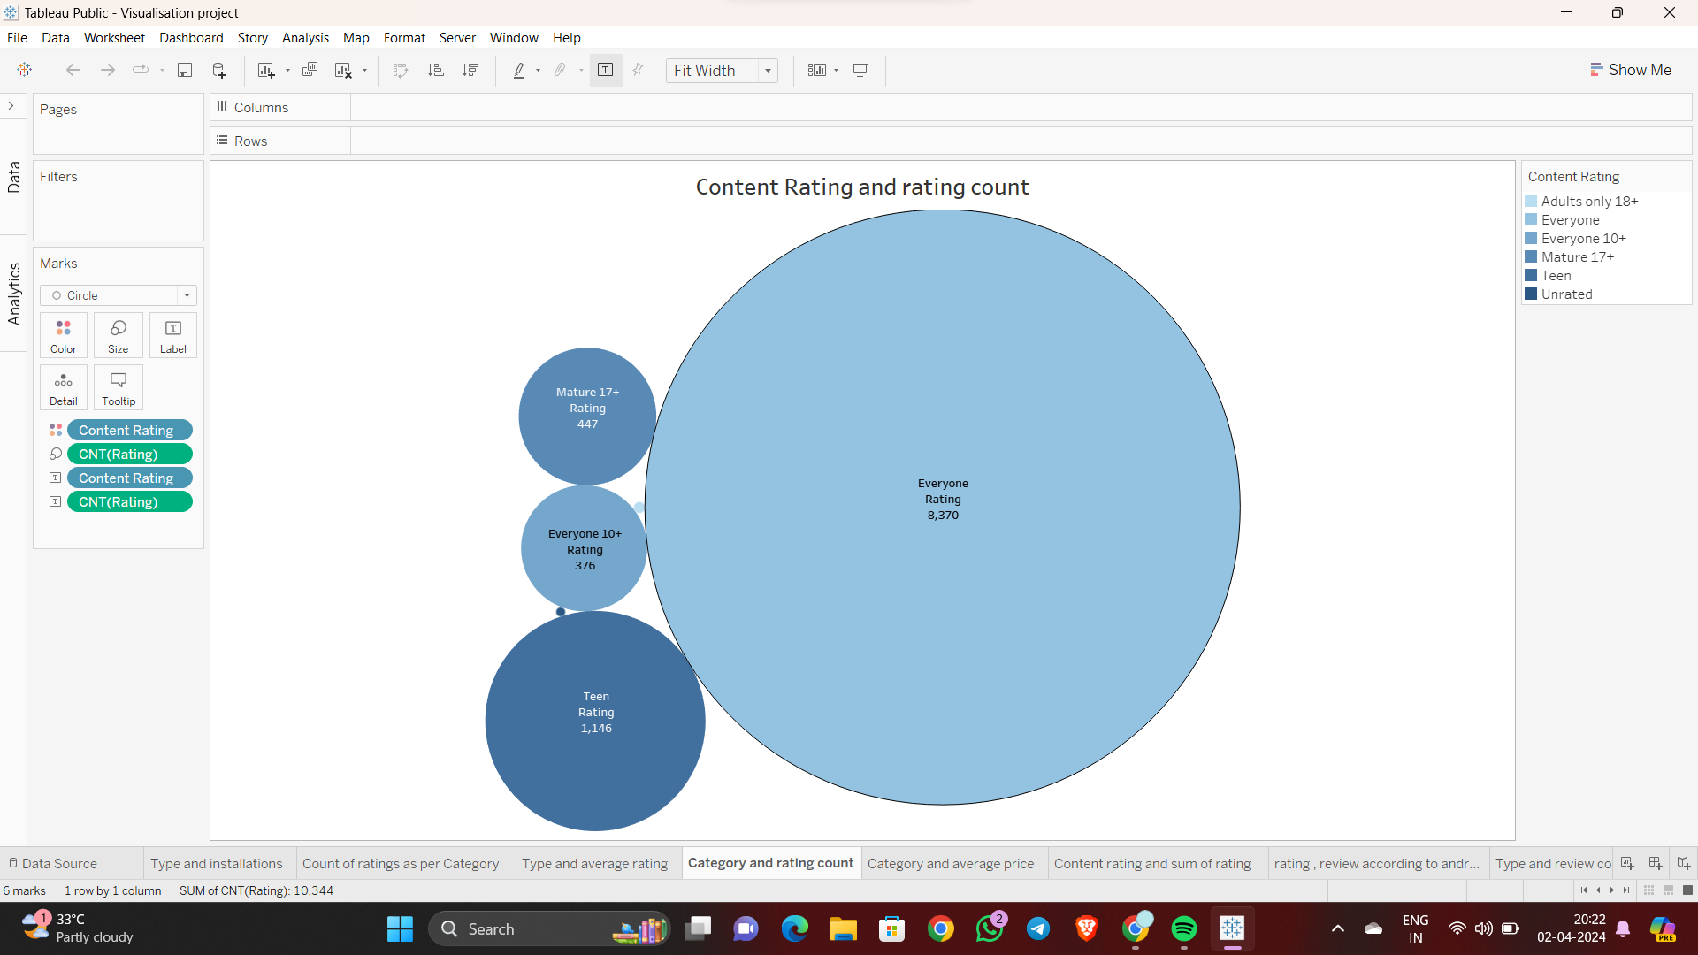

**Insight**

We can see here that the apps used by everyone are having the highest number rating count followed by teen, mature 17+, and so on.

**Business Impact**

A bubble chart displaying content rating against rating count offers a visual representation of user sentiment and engagement levels across different content types. This insight can drive decisions on content creation, marketing strategies, and product development, aiming to enhance user satisfaction, increase engagement, and optimise revenue streams.

**5. Category and average price:**

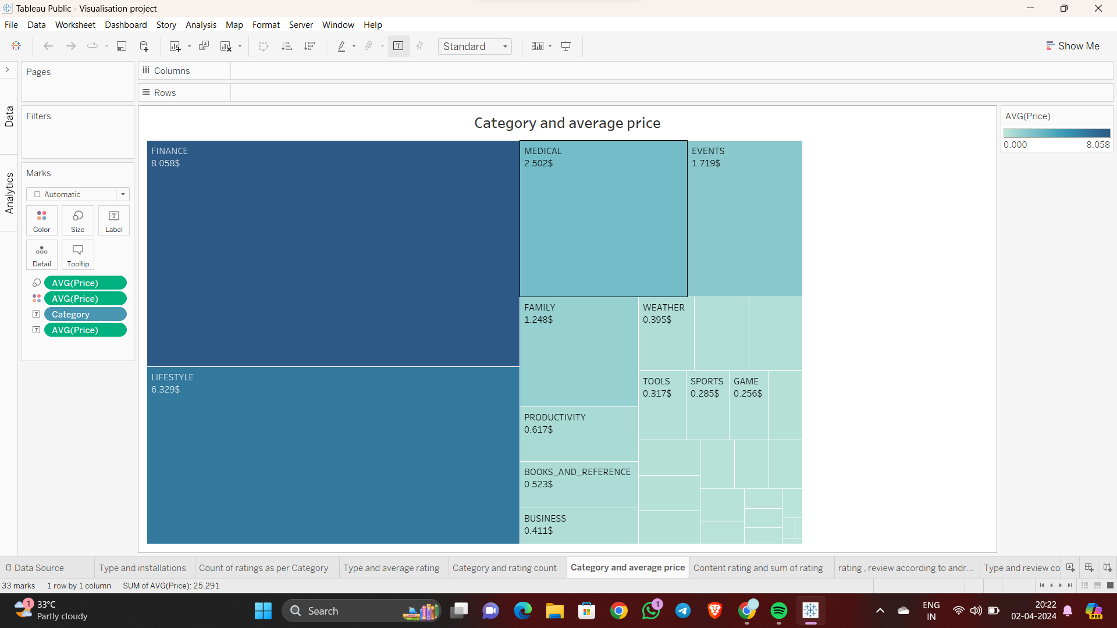

**Insight**

We can see in this chart various categorical apps are having various average pricing. finance category are having the highest average price of 8.05$, lifestyle category carries 6.3$,medical 2.59$ and so on.

**Business Impact**

We can see that there are a number of strong correlations between the different features of apps. For example, there is a strong positive correlation between the number of reviews an app has and its rating. This means that apps with more reviews tend to have higher ratings. There is also a strong positive correlation between the number of downloads an app has and its rating. This means that apps with more downloads tend to have higher ratings.

**6. Content rating and sum of rating:**

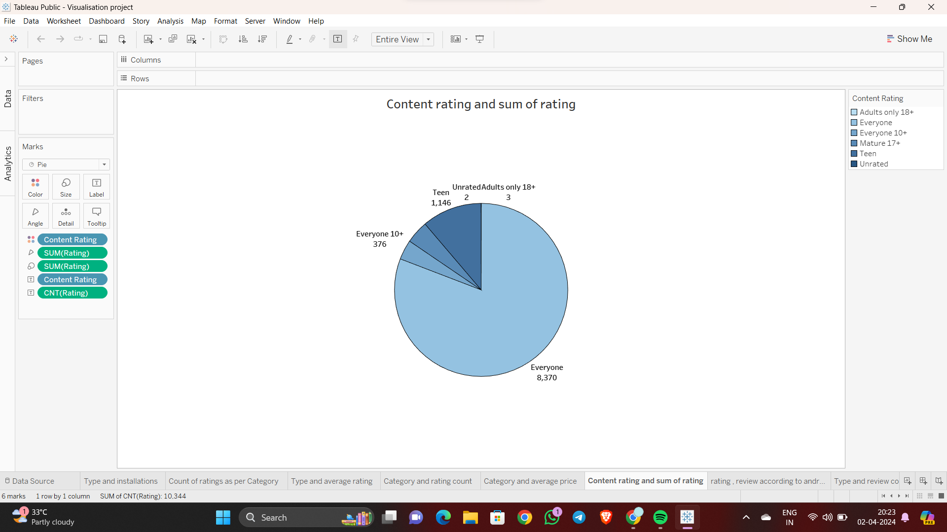

**Insight**

In this chat we can easily see that the apps used by everyone are having the highest count of rating 8370 where rest are having way less then the everyone category as shown in the chart.

**Business Impact**

The insights gained from the scatter plot can help developers understand the most popular content rating categories. This information can be used to develop new apps in popular content rating categories or to improve existing apps in popular content rating categories. This can help to attract more users and increase revenue.

**7. rating , review according to android version**

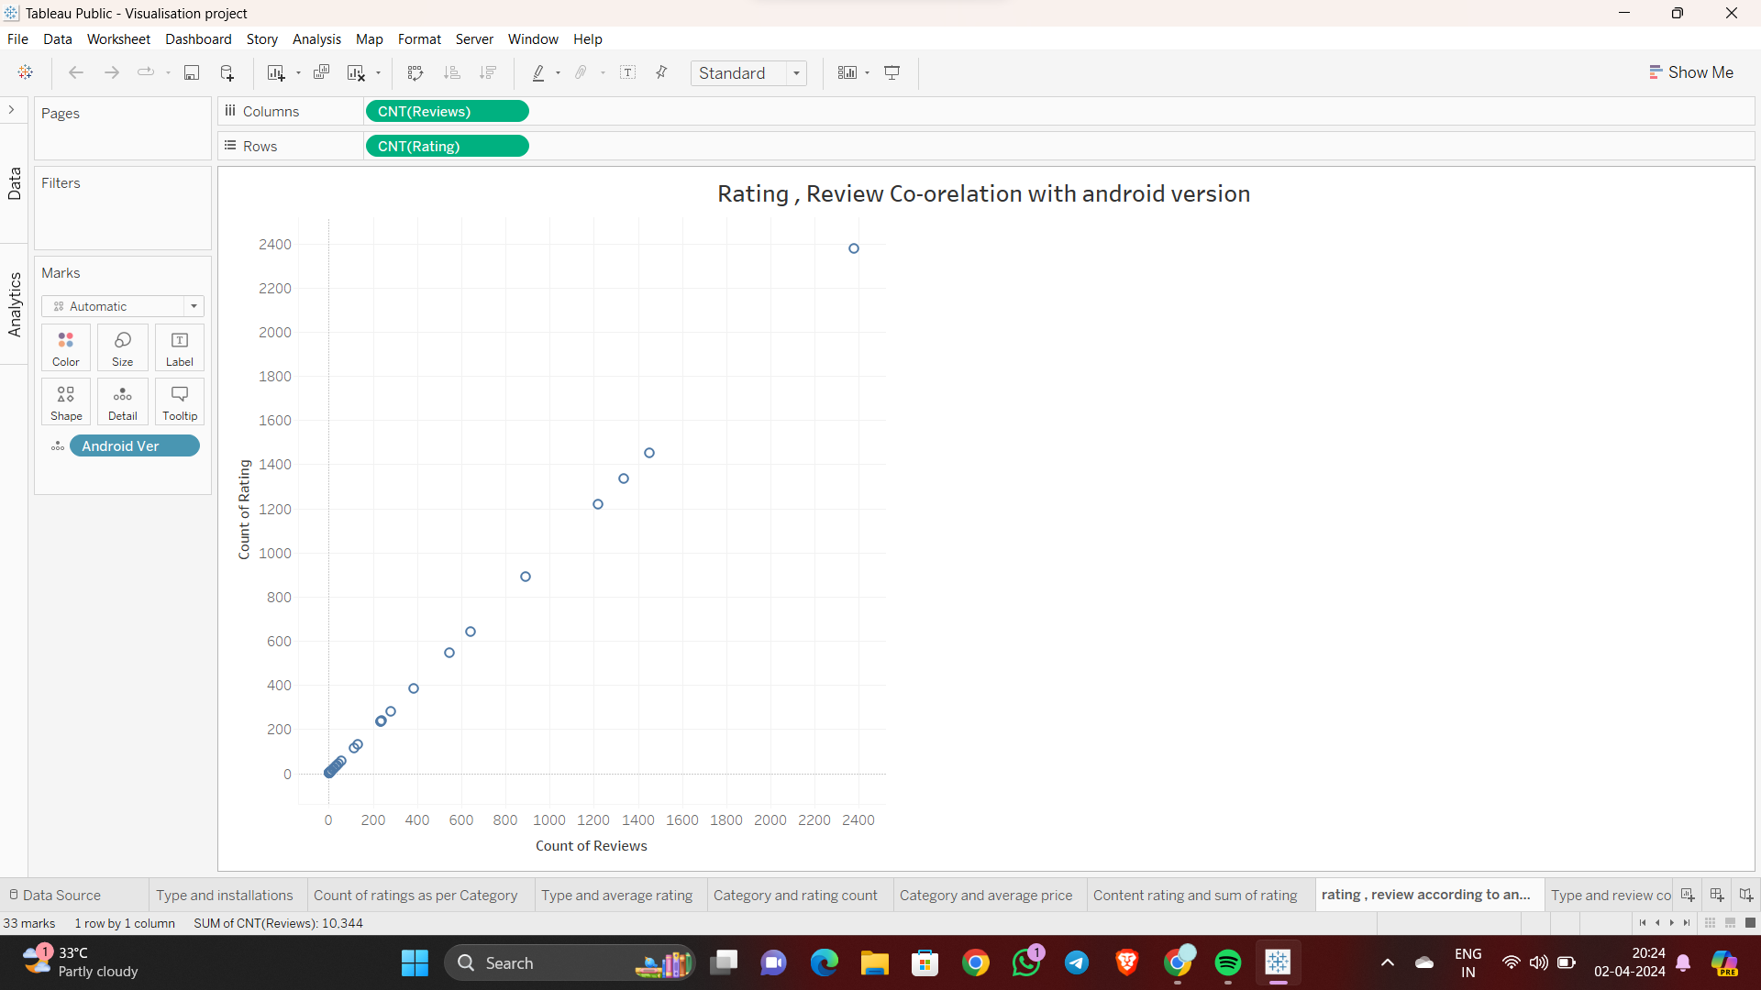

**Insight**

With the help of this pie chart we can see that the West region has the highest sales and the South region has the lowest sales.

**Business Impact**

The insights gained from the scatter plot can help developers understand the relationship between the number of reviews an app has and its rating. This information can be used to make decisions about how to promote their apps and improve their ratings. For example, developers may decide to focus on getting more reviews for their apps, or they may decide to improve the quality of their apps in order to get higher ratings.

**8. Type and review count:**

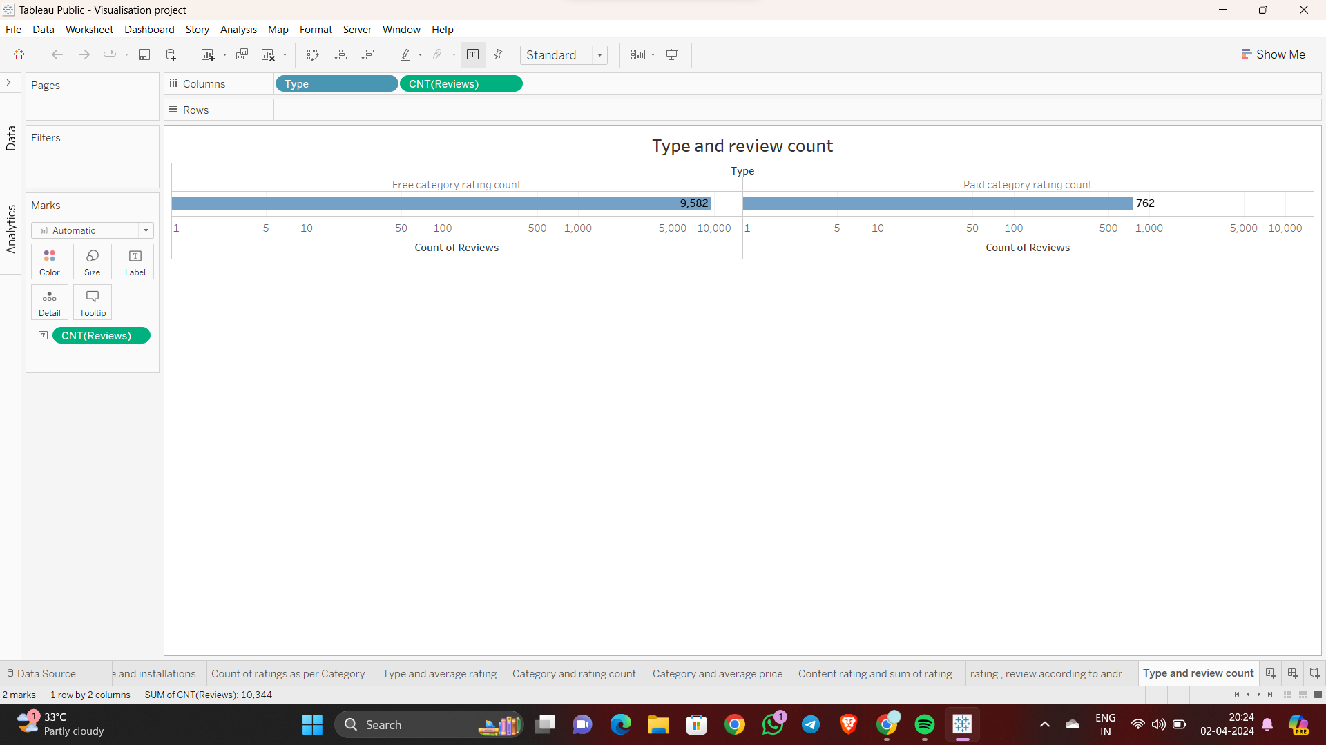

**Insight**

With the help of this chart we can easily compare and count the total review of both free and paid categorical applications. Here we can see free apps have the count of 9582 whereas paid category apps have only 786.

**Business Impact**

A line chart illustrating type and review count reveals trends in user feedback across different product types. This insight informs decisions on product improvements, customer satisfaction initiatives, and resource allocation, ultimately enhancing product quality, customer loyalty, and competitive advantage.

**9. Rating according to types and category:**

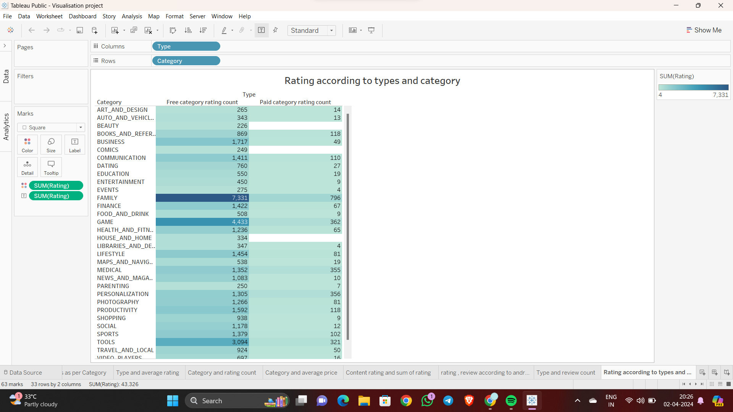

**Insight**

We can observe the ratings of the apps according to their types and category.

**Business Impact**

This showcasing ratings according to types and categories provides a comprehensive overview of user preferences and satisfaction levels across different product segments. This enables businesses to tailor marketing strategies, refine product offerings, and allocate resources effectively, ultimately enhancing customer satisfaction, loyalty, and profitability.

**10. App count in each category:**

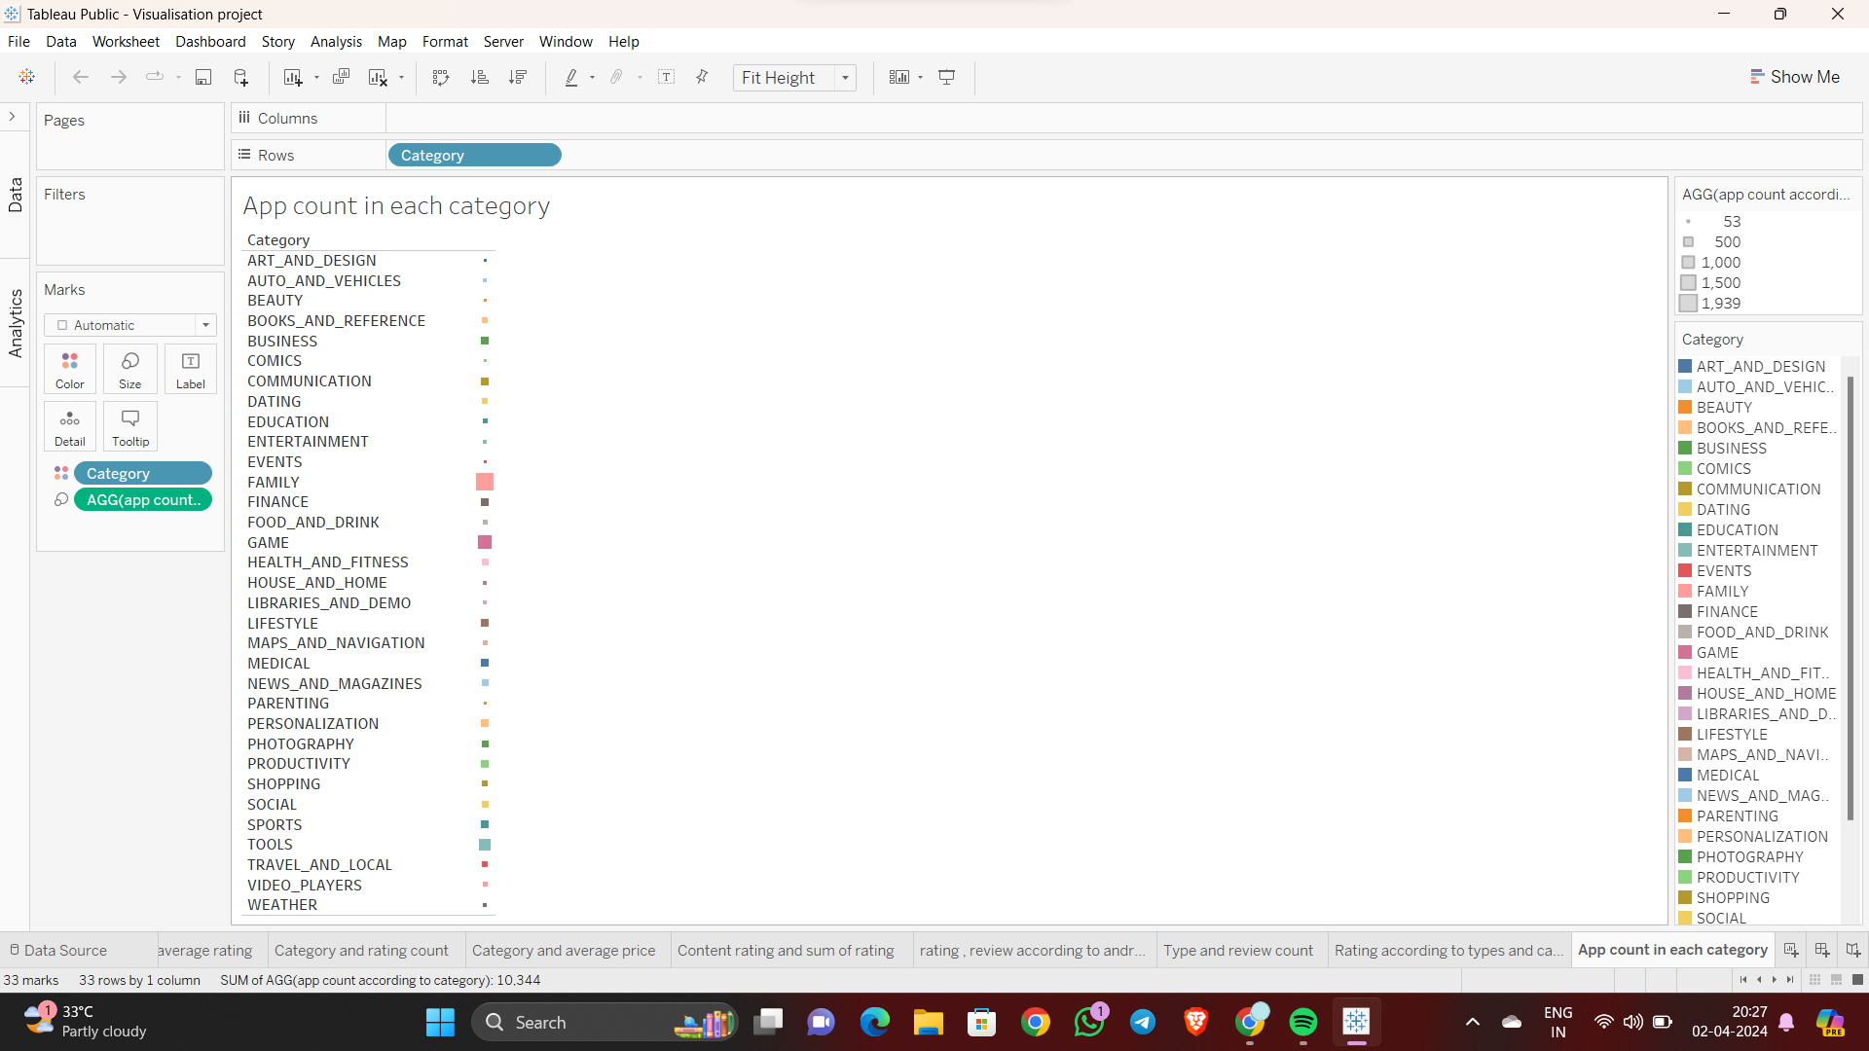

**Insight**

With the help of this chart we can observe the total number of apps available in each category.

**Business Impact**

The count of apps in each category provides insights into market demand and competition within various app categories. This data helps businesses identify lucrative sectors for investment, optimise marketing strategies, and understand consumer preferences, ultimately enabling better decision-making to maximise profitability and market share.

**11. Dashboard:**

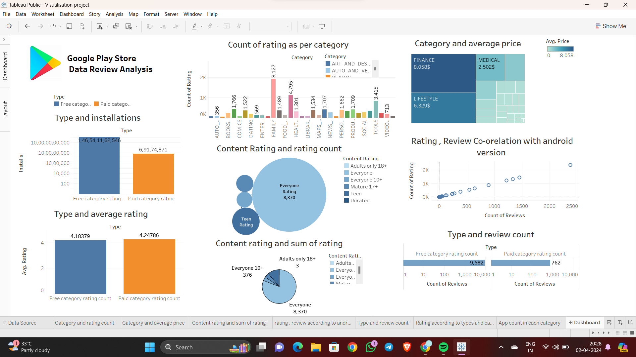

**Tableau Public link:**

<https://public.tableau.com/views/Visualisationproject_17131153855150/Dashboard1?:language=en-US&publish=yes&:sid=&:display_count=n&:origin=viz_share_link>

**Solution to Business Objective:**

There are a number of things that the client can do to achieve their business objective of increasing the number of downloads for their app.

First, the client should focus on improving the quality of their app. This means making sure that the app is bug-free, easy to use, and has a good user experience. The client can do this by conducting user testing, getting feedback from users, and fixing any bugs that are found.

Second, the client should focus on marketing their app. This means creating a strong marketing plan that includes using social media, email marketing, and paid advertising. The client should also make sure that their app is listed in relevant app stores and that the app's listing is optimized for search engines.

Finally, the client should focus on customer service. This means responding to customer inquiries quickly and resolving any issues that customers may have. The client should also make sure that their app has a strong customer support system in place.

By following these tips, the client can increase the number of downloads for their app and achieve their business objective.

**Conclusion:**

In conclusion, this report has provided a comprehensive analysis of the data provided by the client. The analysis has revealed a number of insights that can be used to help the client achieve their business objective of increasing the number of downloads for their app.

The client should focus on improving the quality of their app, marketing their app, and providing good customer service. By following these tips, the client can increase the number of downloads for their app and achieve their business objective.